1. **In pairs, discuss what you should do and what you should not do to protect your data.**

**Possible answer:**

One way to ensure that messages and attachments remain confidential is to transmit them through an encryption platform that integrates with existing systems and workflows. To safeguard data in transit against malware attacks or intrusions, network security solutions like firewalls should be implemented.

Encryption plays a large role in this step and it should be based on the latest standards by only allowing secure protocols.

**Your answer:**



**Read the text below and fill in the blanks with only one word:**

Flash memory is an electronic (solid-state) non-volatile computer storage medium that can be electrically erased and reprogrammed. Toshiba developed flash memory in the early 1980s. Unlike RAM, which is **1)_________**, flash memory retains the information stored in the chip when the power is turned off. This makes it ideal for use in digital cameras, laptops, PDAs, mobile phones, network switches, synthesizers, video games, scientific instrumentation, industrial robotics, and medical electronics. In addition to being non-volatile, flash memory offers fast 2) **________** access times. Flash memory stores information in an array of memory cells made from floating-gate transistors. In single-level cell (SLC) devices, each cell stores only one bit of **3)_________**. Multi-level cell (MLC) devices, including triple-level cell (TLC) devices, can **4)_____________** more than one bit per cell.

The chips are **5)__________** with either NAND or NOR logic gates. NOR chips function like a computer’s **6)____________**, while NAND works like a hard drive. For example, in a camera NOR flash **7)__________** the camera’s internal software, while NAND flash is used to **8)____________** the images.

Flash memory is used in several ways:

* Many computers have their BIOS stored on a flash memory so it can be **9)________** if necessary;
* Modems use flash memory because it allows the manufacturer to **10)_________** new protocols;
* USB flash are used to save and move data files. They are more easily **11)** **_________**because they use solid-state technology;
* U3 smart data drives allow users to store both applications and data.

Flash cards are as small as a stamp and their capacity can range from 8MB to **12)_______** gigabytes. Flash memory storage offers unique benefits to enterprises that are **13)_________** with exploding data **14)__________** and slow, unpredictable data access. As all-flash memory storage solutions become increasingly **15)____________** relative to spinning disk, individual customers and enterprises can now realize flash benefits at scale, including...

3. **Now complete the text with your own ideas relating to the benefits (A) of flash storage. Then, consider some of the disadvantages (B) of flash storage.**

**(A)**

1.

2.

3.

4.

5.

**B)** Advances in technology have made flash storage or solid-state drives (SSD) far more common. In fact, flash storage is slowly taking the place of the more traditional hard disk drives (HDD) people are generally more familiar with. That doesn’t necessarily mean that hard drives will go away completely, but it’s become clear that flash storage is trending upward and may one day become the dominant storage option for individuals and businesses. With this in mind, it’s important to note why flash storage has increased in popularity while also examining the drawbacks that might prevent it from receiving universal adoption. Some of the most important disadvantages of flash storage are:

1.

2.

3.

(...)

4. **In pairs, choose a flash-based device that you own and describe it. Use the Useful language box to help you**.

**5.** 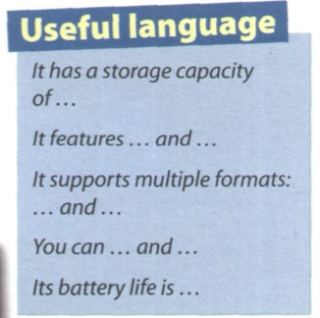

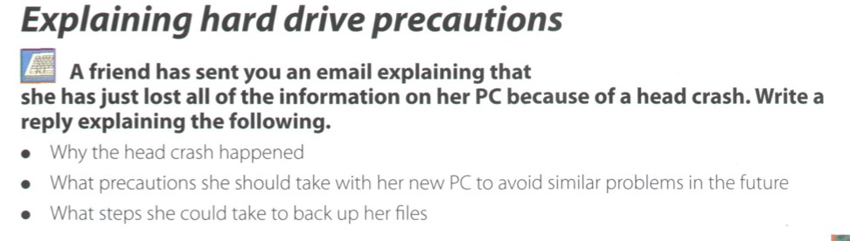

**1. A device for every need: Assistive technology**

**In pairs, discuss the following questions:**

1. what sort of difficulties do you think are experienced by computers users with limitations of vision or mobility?

2. what types of device could be helpful to visually impaired users?

3. how can a person with limitations of mobility communicate with a computer?

**Solution Generation: Tools/Strategies**

**2. One of the most important questions when assessing a student’s need for assistive technology is: *What are the tasks the student needs to do?***

These are some questions to consider:

* the student needs to access educational/special software to enhance participation in the curriculum;
* the student needs to independently complete written work (reports, worksheets);
* the student needs to navigate the Internet/ use email;
* the student needs to take notes;
* the student needs to take tests;
* the student needs to show their work in Computer Science;

**As a team, brainstorm and list any assistive technologies and/or strategies you think will assist the student in successfully completing the tasks above.**